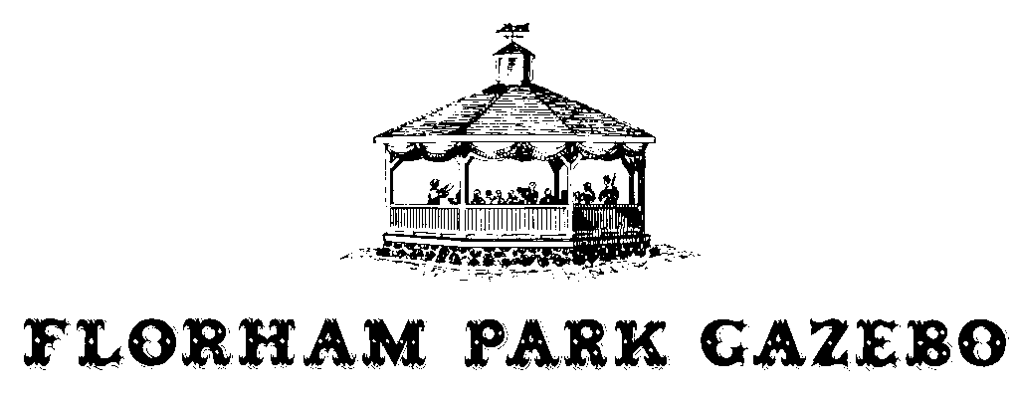
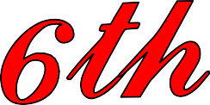
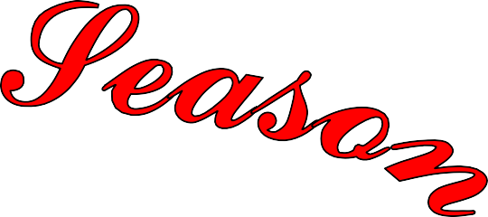

2026 Concert Series ~ 46 years of volunteer service
 | Mark Taylor ~ Mayor
Sunday, June 7 | Street Hassle
7:00 p.m. | An energetic and entertainingly engaging band performing Classic Rock, Blues, Motown & Pop with an incredibly powerful horn section.
Sunday, June 14 | Big Hix - the Nation's most exciting, authentic, & fun country music tribute band
7:00 p.m. | Non-stop high energy country hits from Kenny Chesney & Luke Bryan to 90's gems from Garth Brooks and Travis Tritt to old-school classics of Nelson, Haggard and Cash.
Sunday, June 28 | Beatlemania Again
7:00 p.m. | The National Touring Beatles Stage Show "Beatlemania Again". Relive the Music, The  Magic & The Mania … Live on Stage!
Sunday, July 12 | Forever Ray … The exciting and uplifting music of Ray Charles
7:00 p.m. | Performing a wonderful blend of musical styles ranging from Jazz and Blues to Country
 | R&B to sell-out audiences throughout the NY Metropolitan area.
Sunday, July 19 | Take Two
7:00 p.m. | Performing music from the 1960s through today. There's something
 | for everyone!
Sunday, July 26 | The Benjamins
7:00 p.m. | THE legendary high-end act combining classical, modern, elegant, and edgy music elements with an original sound to create something truly unique.
Sunday, August 2 | Jesse Garron's Tribute To Elvis
7:00 p.m. | "The closest thing to the King"
 | Ranked among the most respected acts in local and nationwide venues.
Sunday, August 9 | Separate Ways
7:00 p.m. | The closest you'll get to see of the early-mid 80's line-up of Journey live, EVER. Don't miss the Ultimate Tribute to the music of Journey.

If weather is questionable please visit the web site for concert status ~ www.florhamparkgazebo.com
* PLEASE DO NOT call the police department regarding concert information *

